Experiment 1
AIM: To find the roots of a quadratic equation using C++.
Description / Problem Statement
A quadratic equation ax2+bx+c=0ax2+bx+c=0 has roots determined by the discriminant (D=b2−4acD=b2−4ac):
- Real and distinct roots if D>0D>0.
- Real and equal roots if D=0D=0.
- Complex roots if D<0D<0.
The program must:
- Accept coefficients aa, bb, and cc as input.
- Validate that a≠0a=0 (to ensure it is quadratic).
- Compute the discriminant and determine the nature of the roots.
- Output the roots with appropriate formatting (real or complex)
PROGRAM:
#include <iostream>
#include <cmath> // for sqrt() function
using namespace std;

int main()
{
float a, b, c;
cout << "Enter coefficients a, b and c: ";
cin >> a >> b >> c;

float discriminant = b*b - 4*a*c;
float root1, root2;

if (a == 0) {
cout << "This is not a quadratic equation (a cannot be 0)." << endl;
}
else if (discriminant > 0) {
// Real and distinct roots
root1 = (-b + sqrt(discriminant)) / (2*a);
root2 = (-b - sqrt(discriminant)) / (2*a);
cout << "Roots are real and distinct." << endl;
cout << "Root 1 = " << root1 << endl;
cout << "Root 2 = " << root2 << endl;
}
else if (discriminant == 0) {
// Real and equal roots
root1 = root2 = -b / (2*a);
cout << "Roots are real and equal." << endl;
cout << "Root = " << root1 << endl;
}
else {
// Complex roots
float realPart = -b / (2*a);
float imagPart = sqrt(-discriminant) / (2*a);
cout << "Roots are complex and imaginary." << endl;
cout << "Root 1 = " << realPart << " + " << imagPart << "i" << endl;
cout << "Root 2 = " << realPart << " - " << imagPart << "i" << endl;
}

return 0;
}
OUTPUT:
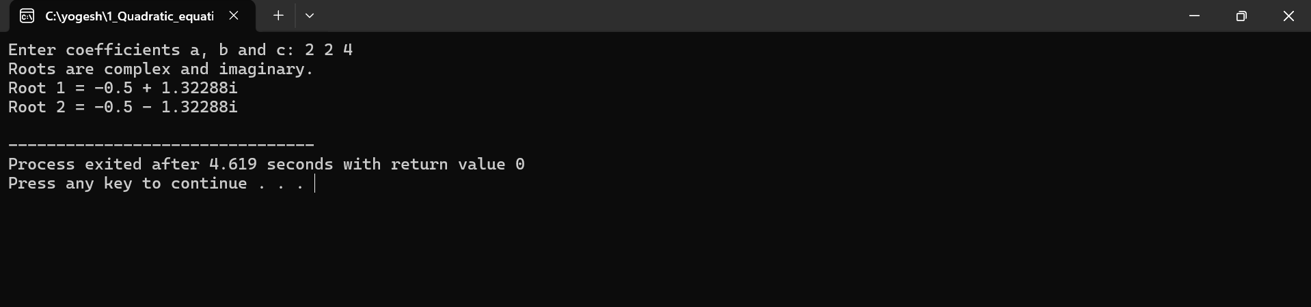
Result / Conclusion:
The program successfully determines the nature of roots of a quadratic equation and calculates them accurately, handling cases for real and distinct, real and equal, and complex roots.

Experiment 2
AIM: Find factorial of a given number using recursion
Description / Problem Statement:
The factorial of a number nnn (denoted as n!n!n!) is the product of all positive integers less than or equal to nnn.
Mathematically,
n!=n×(n−1)×(n−2)×⋯×1n! = n \times (n-1) \times (n-2) \times \dots \times 1n!=n×(n−1)×(n−2)×⋯×1
with the special case 0!=10! = 10!=1.
This program computes the factorial of a given positive integer using recursion — a process where a function calls itself to solve smaller subproblems. The recursive logic is:
- Base case: If n=0n = 0n=0 or n=1n = 1n=1, return 1.
- Recursive case: n!=n×(n−1)!n! = n \times (n-1)!n!=n×(n−1)!.
The program reads the number from the user, applies the recursive function, and displays the result.

PROGRAM:
#include <iostream>
using namespace std;

// Recursive function to calculate factorial
long factorial(int n)
{
if (n == 0 || n==1)
return 1;
else
return n * factorial(n - 1);
}

int main()
{
int number;

cout << "Enter a positive integer: ";
cin >> number;

if (number < 0)
{
cout << "Factorial is not defined for negative numbers." << endl;
}
else
{
long result = factorial(number);
cout << "Factorial of " << number << " = " << result << endl;
}

return 0;
}
OUTPUT:
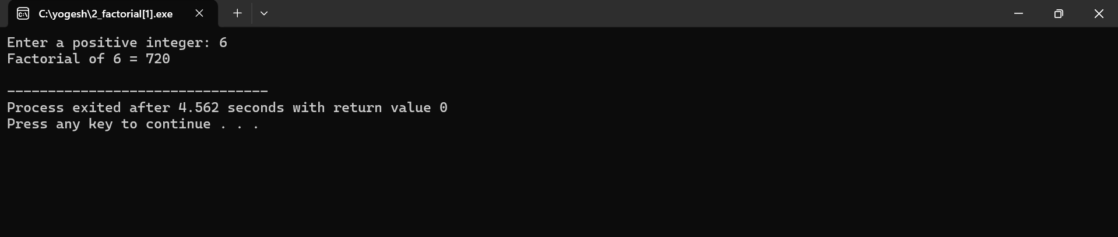
Result / Conclusion
The program successfully:
- Computes factorials recursively by breaking the problem into smaller subproblems (e.g., 5!=5×4!5!=5×4!).
- Handles the base case (n=0n=0) to terminate recursion.
- Validates input to reject negative numbers.

Experiment 3
AIM: Implement scope resolution and namespaces.
Description / Problem Statement
In C++, namespaces group related code elements (variables, functions, classes) to prevent naming collisions. The scope resolution operator (::) allows explicit access to these elements when:
- A local variable shadows a global variable.
- Functions/classes with identical names exist in different namespaces.
- Accessing static class members or nested namespaces.
The program must:
- Create multiple namespaces (e.g., Math, Physics).
- Define variables/functions with the same name in different namespaces.
- Use :: to access global variables, namespace members, and nested namespaces.
- Demonstrate resolving ambiguity between local and global variables

PROGRAM:
#include <iostream>
using namespace std; // using standard namespace

int x = 100; // Global variable

namespace MyNamespace
{
int value = 50;

void show()
{
cout << "Inside MyNamespace, value = " << value << endl;
}
}

int main()
{
int x = 10; // Local variable

cout << "Local x = " << x << endl;
cout << "Global x = " << ::x << endl; // Using scope resolution to access global x

// Accessing namespace variable and function
cout << "Namespace value = " << MyNamespace::value << endl;
MyNamespace::show();

return 0;
}
OUTPUT:
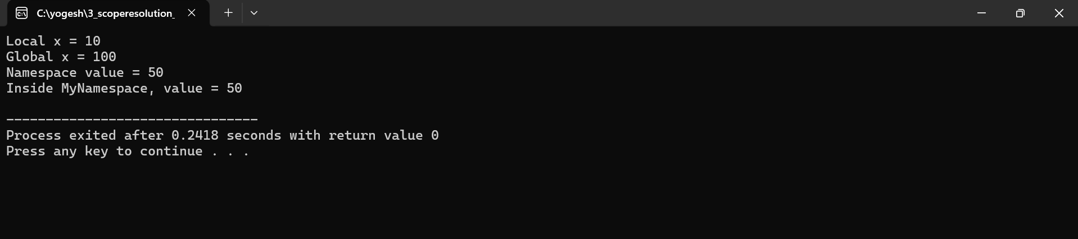
Result / Conclusion
The program successfully:
- Resolves naming conflicts using namespaces (e.g., Math::calculate() vs. Physics::calculate()).
- Accesses global variables with :: when local variables have the same name.
- Implements nested namespaces (e.g., Project::Utilities::print()) and accesses them via ::

Experiment 4
Aim: Illustrate the use of default arguments and access specifiers
Description / Problem Statement
- Default Arguments:
  - Allow functions to assign predefined values to parameters if no arguments are provided.
  - Must be specified in function declarations (not definitions) and follow positional constraints (trailing parameters only)
- Access Specifiers:
  - Control visibility of class members:
    - public: Accessible from anywhere.
    - private: Accessible only within the class.
    - protected: Accessible within the class and derived classes
  - Classes default to private access, while structs default to public.
The program must:
- Create a class with members under different access specifiers.
- Implement a function with default arguments to handle multiple use cases.
- Demonstrate access restrictions (e.g., attempting to access private members directly will fail).
PROGRAM:
#include <iostream>
using namespace std;

class Student
{
private: // it is the default access specifier
int sno; // Private: accessible only inside the class
protected:
string sgrade; // Protected: accessible in derived classes
public:
string sname; // Public: accessible from outside

// Constructor
Student(int sn, string sna, string sg)
{
sno = sn;
sname = sna;
sgrade = sg;
}

// Function with default arguments
void disp(string sgrade = "Pass")
{
cout << " Name: " << sname << endl;
cout << "Roll Number: " << sno << endl;
cout << "Grade: " << sgrade << endl;
}
};

int main()
{
Student s1(100, "Rajesh", "A+"); // Creating object

cout << "Name of the Student ="<< s1.sname << endl; // accessing public variable

s1.disp();
s1.disp("Distinction");
s1.disp();

return 0;
}
OUTPUT:
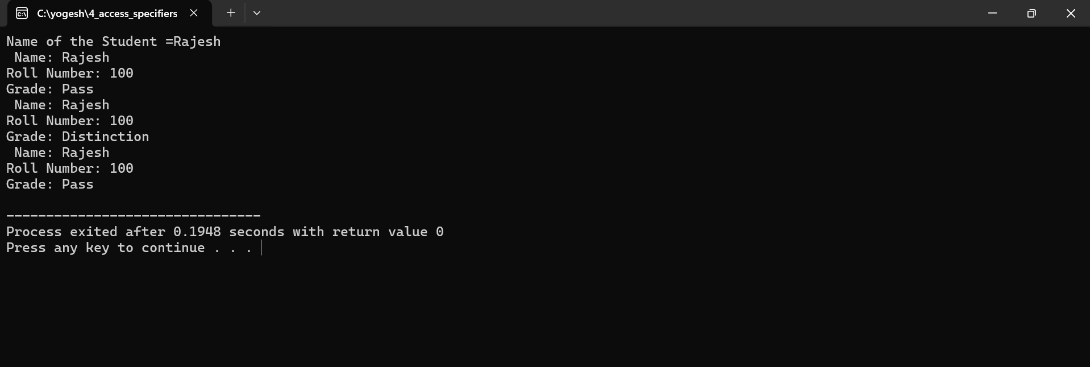
Result / Conclusion
The program successfully:
- Default Arguments:
  - Executes functions with omitted parameters, using predefined defaults (e.g., printMessage("Hello") and printMessage() with a default message).
- Access Specifiers:
  - Enforces encapsulation by restricting direct access to private/protected members (e.g., compile-time error when accessing private variables outside the class).
  - Allows controlled access via public methods (e.g., getPrivateData() to retrieve private values)

